Viator API certification - front-end checks (v2 API)

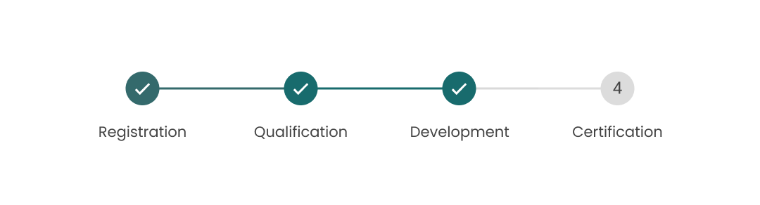
How to get started
- Please check our certification documentation before submitting answers.
- Please fill in your answers to the form below.
- Send this document back to us at affiliateapi@tripadvisor.com.
- We will verify your integration and ensure everything is in working order.
- We will reach out directly to you via email with additional questions or to let you know you've completed the front-end checks.

Why certification is important
The purpose of this certification is to verify that Viator content is correctly implemented into your platform and to verify that only valid booking data will be submitted to our tour operators. This way you will avoid issues with bookings in your live implementation.
The certification will consist of:
Front-end (UX/UI) checks
These involve providing screenshots of various elements of your site's booking UX/UI; e.g., the search, product selection, product detail, and checkout stages as well as customer communication.
Back-end checks
These will require you to document the major elements of your back-end workflow to ensure efficiency and accuracy. We will also use this documentation to help in providing technical support for your integration, rather than having to request this information from you if a problem arises.
This form is used only for front-end checks. In order to complete back-end checks we will ask you to provide answers to questions about endpoint usage in the file available here: Viator API certification: back-end checks.
Disclaimer: All question-specific products are valid as of 7 July 2025. If you notice a product is no longer live, or if a certain product is excluded by your business strategy, please contact your API Integrations contact, and we will be happy to find alternatives.

Documentation
If you are unsure whether certain elements have been implemented correctly, please refer to the documentation below:
· API documentation: https://docs.viator.com/partner-api/technical/
· Implementation guides: https://partnerresources.viator.com/travel-commerce/implementation/

Partner details
Please provide a brief summary of your organization, and your business strategy for this integration.

- Company name
- PUID/partner unique ID (if known)
- Email address

Implementation details
- Link to test/staging environment
- Select all which apply to your integration
- Business to consumer sales
- Business to business sales
- Travel agent sales
- Desktop Site
- Mobile App
- Other:

- Will you sell manual confirmation type products? If not, please confirm that you have a logic to filter them out.
Please note: Bookings for manual confirmation type products must be confirmed by the supplier within a 72 h period before they can be confirmed to customers. If you don't support manual confirmation type products they must be filtered out on your end.

- If the reviews or review scoring from the API are used on your site, do you indicate the provider of the reviews (Viator/Tripadvisor)? Please share an example.
Please note: Refer to contractual agreement on requirements to indicate source of reviews.

- Do you display the Viator/Tripadvisor logo anywhere on your site, or mention Viator/Tripadvisor in any way other than next to the reviews/ review scoring?

- Is there anything we need to know about your implementation? In case you are not able to answer any questions from this form, please clarify why.

User flow and platform navigation
Resources:
- API documentation - Resolving references
- Partner Resource Center - Front-End Guide for API Partners

- Please briefly describe your platform's user-flow. How would a theoretical user move from your landing page to check-out?

- Please provide a screenshot of your search bar, including contextual search suggestions (if available).
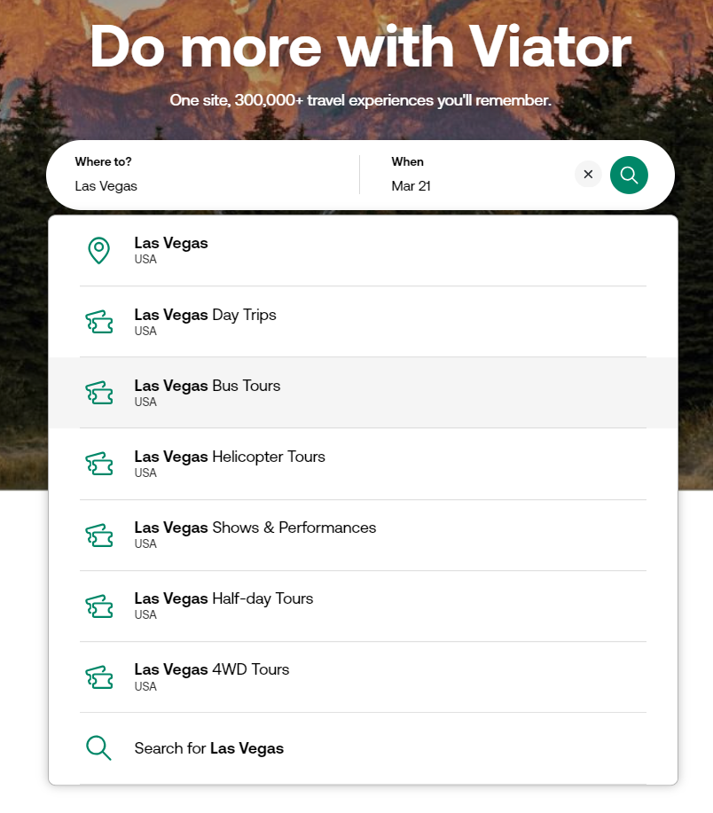
Files submitted:

- What search options do you offer?
Check all that apply.
- Search by destination
- Search by attraction
- Search by product code
- Freetext search
- Other – please specify

Files submitted:

- Please share a screenshot demonstrating the option to filter products by category
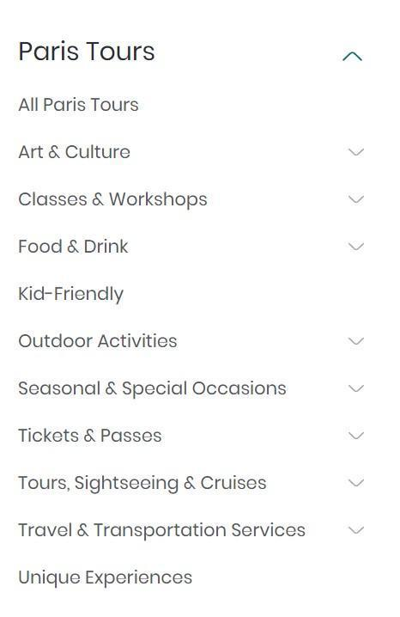
Files submitted:

- Please share a screenshot demonstrating the option to filter products by attraction
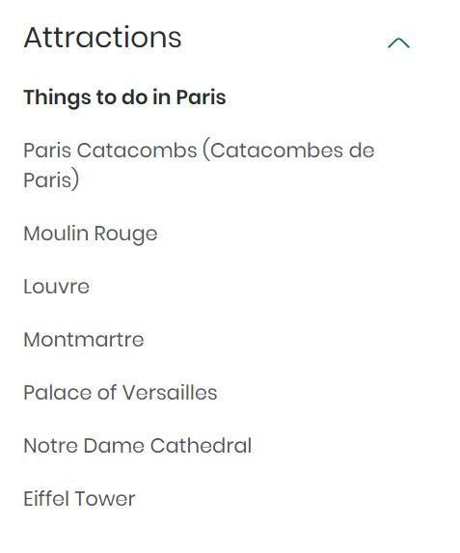
Files submitted:

- Select other filtering options supported in your implementation and share the screenshots to show how they have been implemented in the comments below
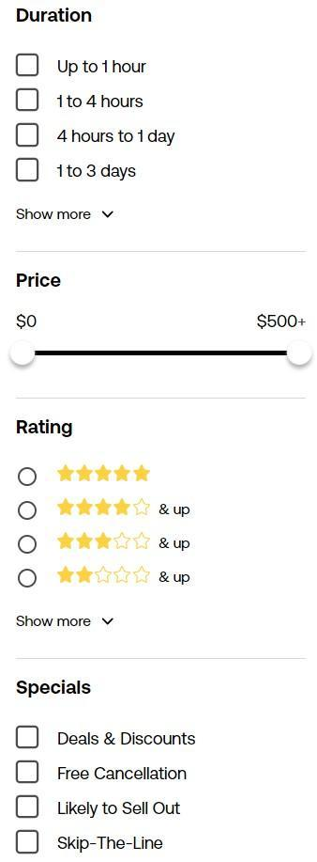

Filtering options:
- Price
- Review rating
- Duration
- Cancellation policy
- Special offers
- Other - please provide details

Files submitted:

- Please share a screenshot demonstrating the available sort order options
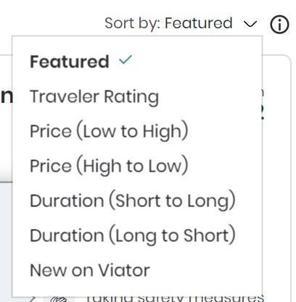
Files submitted:
- What is your default sort order?

- Do you use any of the tags listed below? If so, please provide details on how each tag is used - whether on the front end or in the back-end system.

- 367652 - Top Product
- 21972 - Excellent Quality
- 22143 - Best Conversion
- 22083 - Likely To Sell Out
- 11940 - Once in a Lifetime
- 21074 - Unique experiences
- 6226 - Best Value
- 21971 - Viator Plus
- 367653 - Low Supplier Cancellation Rate
- 367654 - Low Last Minute Supplier Cancellation Rate
- 367650 - Additional Fees
- 367651 - DSA non-compliant
- 367649 - Worry-Free Shore Excursion
- 5184 - Budget
- 22098 - Best Seller
- 21859 - Best Seller
- 6226 - Best Value
- 21873 - Best Seller
- 21971 - Viator Plus
- 22211 - Featured New

Please note:
- These tags may be used for the front-end display:
- 21074 - Unique experiences
- 367648 - Viator Experience Award 2024
- 11940 - Once in a Lifetime
- These tags may be used to create custom sort orders or additional filters in the back-end system. However, most should not be displayed on the front-end:
- 367652 - Top Product
- 21972 - Excellent Quality
- 22143 - Best Conversion
- 22083 – Likely To Sell Out
- 367653 - Low Supplier Cancellation Rate
- 367654 - Low Last Minute Supplier Cancellation Rate
- 367650 - Additional Fees
- 367651 - DSA non-compliant
- These tags may not be used at all as they are not supported for partner use at this time:
- 367649 – Worry-Free Shore Excursion
- 5184 - Budget
- 22098 - Best Seller
- 21859 - Best Seller
- 6226 - Best Value
- 21873 - Best Seller
- 21971 - Viator Plus
- 22211 - Featured New
Files submitted:
Additional comments:

- Do you offer cross-selling options? Please select which options have been applied in your implementation:
- In the booking flow
- Post-booking – confirmation page
- Post-booking – pre-trip email
- Post booking – post-trip email
- Other – please specify
Files submitted:
Additional comments:

- Which marketing tools are you currently using:
- Adverts / banners
- Email campaigns
- Social media
- Members newsletter
- Blog
- Other – please specify

Files submitted:

Additional comments:

Product detail page
Resources:
- API documentation - Product services
- Partner Resource Center - Front-End Guide for API Partners

- Please confirm which product elements you display on the product detail page.
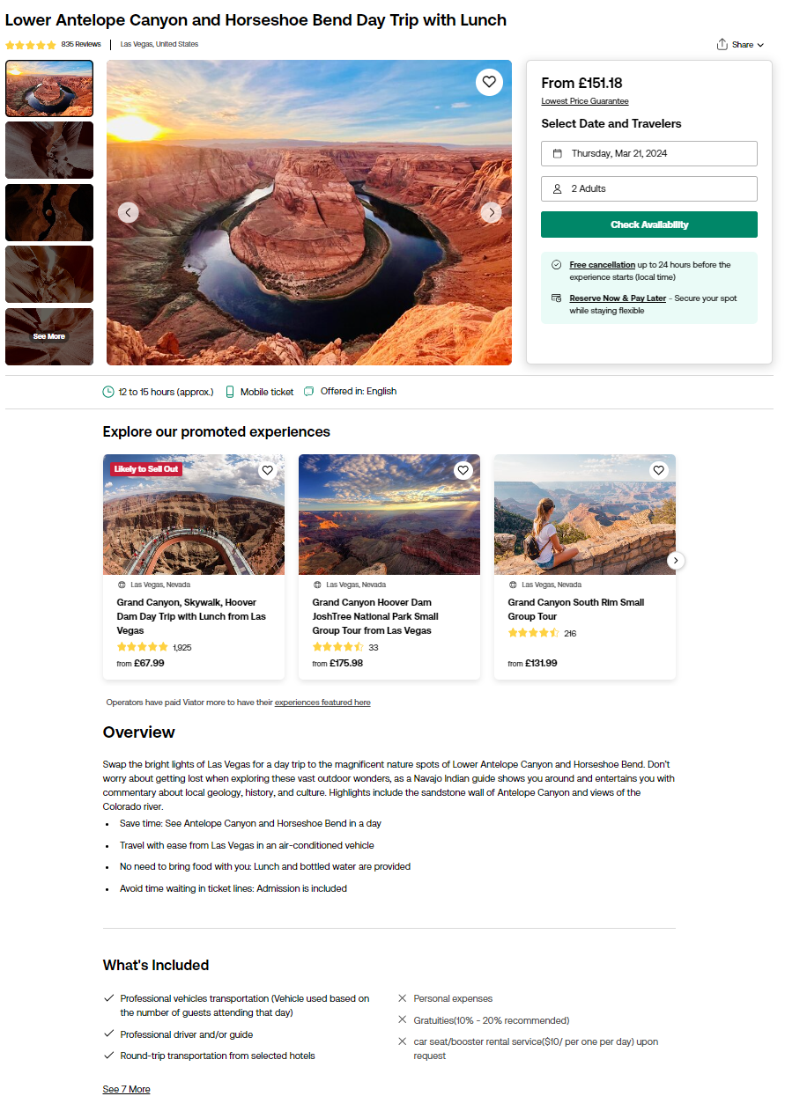

- Product title*
- Average rating
- Supplier photos*
- Traveler photos
- Product description*
- Itinerary*
- Departure time
- Departure point
- Return details
- Duration*
- Inclusions and exclusions*
- Voucher type*
- Additional info*
- Reviews
- Cancellation policy*
- Language guide*
- Other:

*mandatory

- Please demonstrate each of the display elements. Feel free to use as many or as few screenshots as you like, while ensuring all elements are shown.

Files submitted:
Products used, and additional comments

Age bands
Resources:
- API documentation - Working with age bands
- Partner Resource Center - Implementing age bands & pax mix

- Using product 100014P9 or another product with 5 age bands, please use a screenshot to demonstrate that all age bands are shown, and show the correct ages.
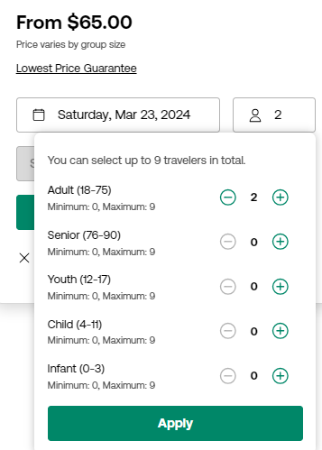
Files submitted:
Additional comments and product code (if different from 100014P9)

- Using product 101924P174, please demonstrate that only the appropriate age bands are displayed - "adult" and "youth".
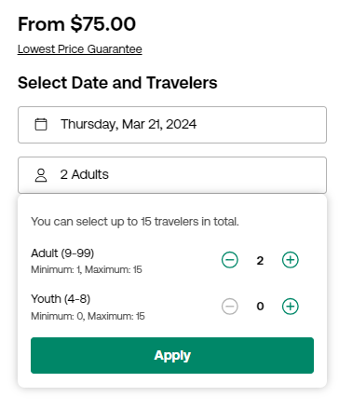
Files submitted:
Additional comments and product code (if different from 101924P174)

- Using product 112604P2 please demonstrate that it's not possible to book for less than 2 and more than 5 travelers.
Please note: Please import and use product 112604P2 for this check, as it needs to be used due to a unique setup. We don’t have an easy way to identify other products configured in the same way. Here, we want to confirm that age bands, as well as the minimum and maximum passenger counts per age band and per booking, are validated based on the /schedules response, in addition to the product content response.
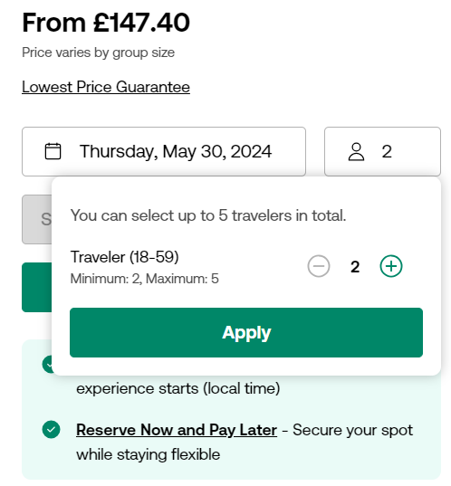
Files submitted:
Additional comments and product code (if different from 112604P2)

- Using product 161734P10 please demonstrate how the minimum and maximum passenger count is validated on age band level (max 10 adults, max 5 children).
Please note: Please use product 161734P10 for this check or another one where the minimum and maximum traveller count differs for different age bands.
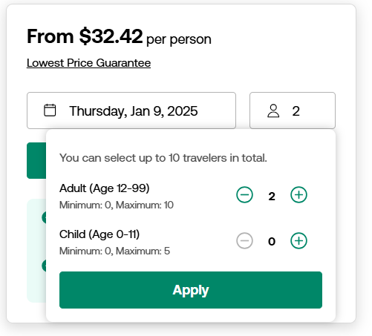
Files submitted:
Additional comments and product code (if different from 161734P10)

- Using product 161734P10 please demonstrate how the minimum and maximum passenger count is validated on booking level (max 10 travelers can book in total).
Please note: Please use product 161734P10 for this check or another one where the minimum and maximum traveller count differs for different age bands.
Files submitted:
Additional comments and product code (if different from 161734P10)

- Using product 177458P2, please demonstrate that it is possible to buy a senior ticket without accompanying adult ticket.
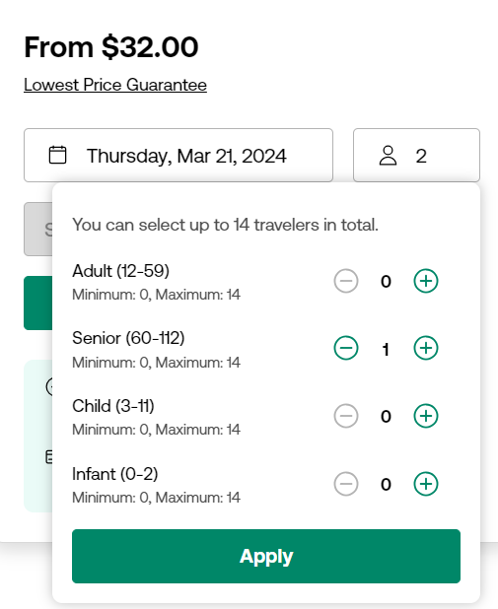
Files submitted:
Additional comments and product code (if different from 177458P2)

- Using product 177458P2, please demonstrate that it is NOT possible to select more than 14 tickets for this product, across at least two different age bands.
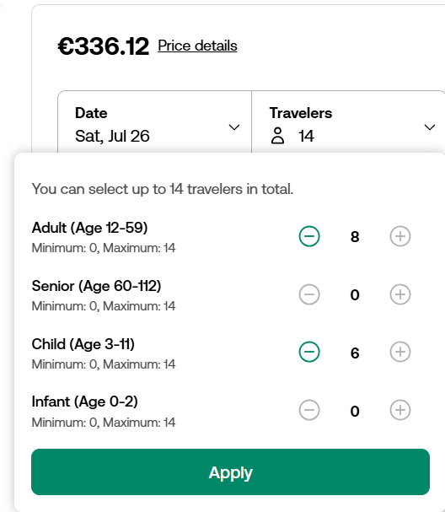
Files submitted:
Additional comments and product code (if different from 177458P2)

- Using product 177458P2, please demonstrate that it is NOT possible to buy a child ticket without accompanying adult ticket ("requiresAdultForBooking": true) - at least one traveller from either ADULT or SENIOR age band is required.
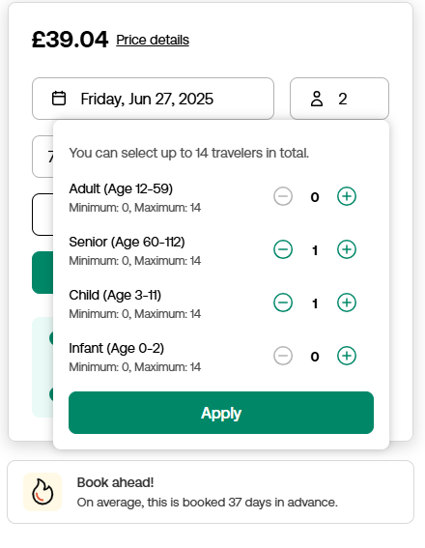
Files submitted:
Additional comments and product code (if different from 177458P2)

Availability and pricing checks
Resources:
- API documentation - Per-person and unit pricing
- Partner Resource Center - Calculating Product Pricing with the Merchant API

- Date Search: Using 161734P10, please show that you can search for availability using date. This product should only be available on Fridays, Saturdays and Sundays.
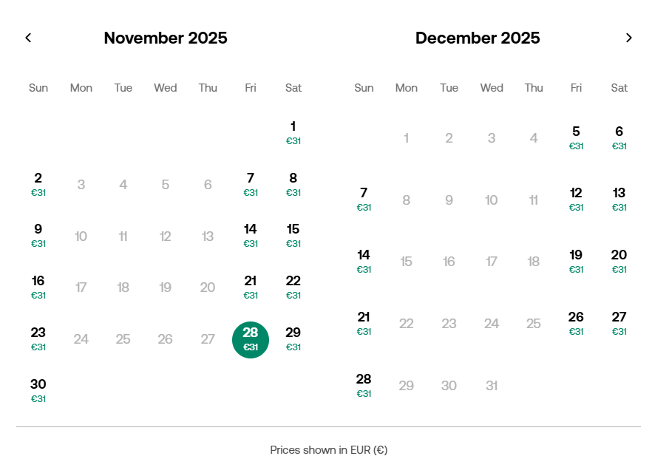
Files submitted:
Additional comments and product code (if different from 161734P10)

- Using any product, please show that you are able to search for availability by date and
passenger mix.
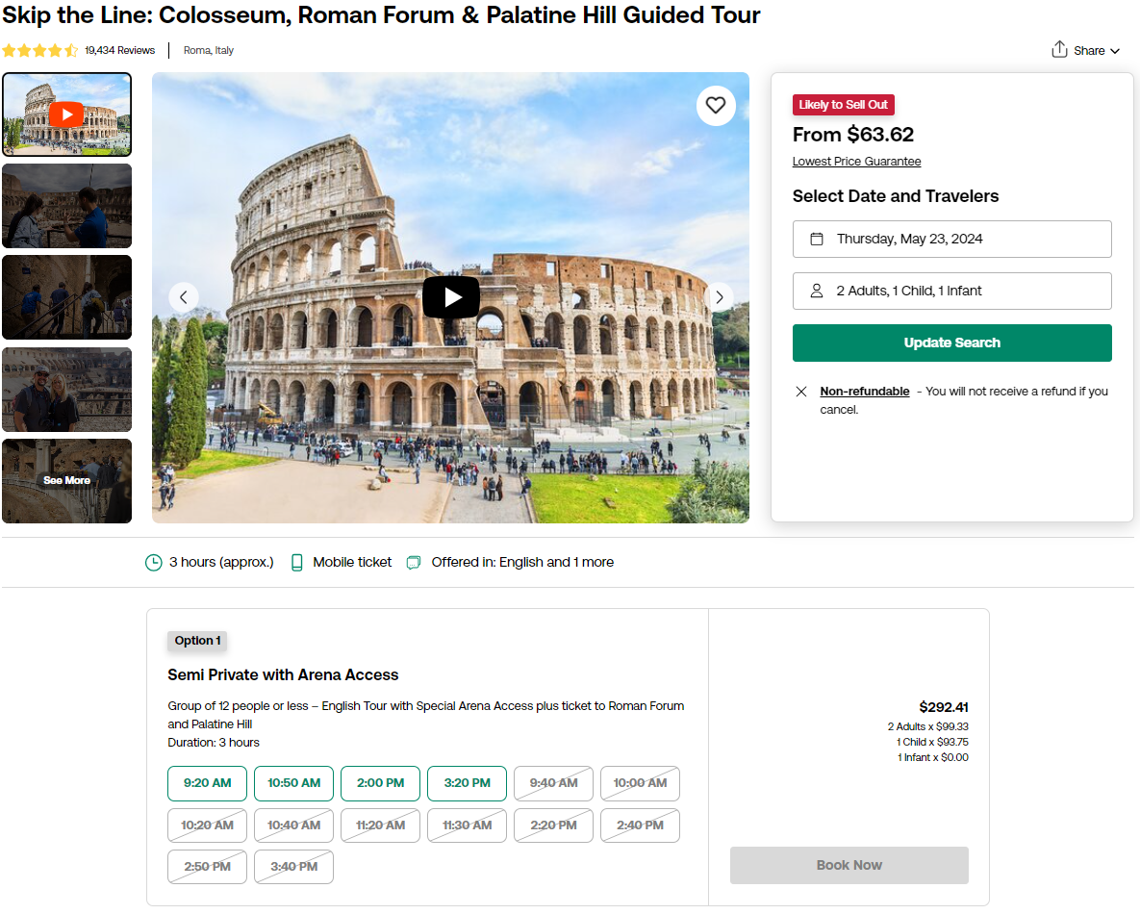
Files submitted:
Product code used, and additional comments

- With product 112604P2, show that per-person pricing is calculated correctly based on the number of participants from each age band. Please share two screenshots - one with a selection of 2 adults and another one with a selection of 3 adults. The per-person price for 2 adults should be higher than the per-person price when 3 adults are selected.
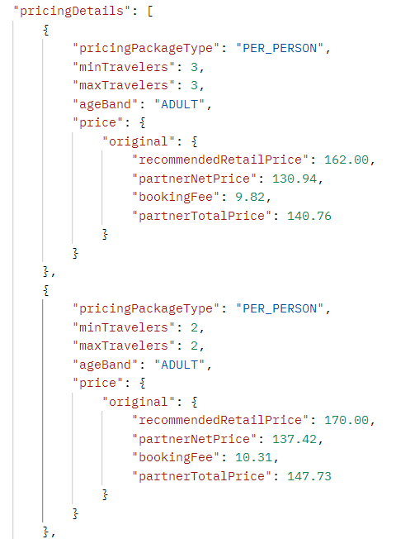
Files submitted:
Additional comments and product code (if different from 112604P2)

- Using product 118238P2 please share two screenshots to demonstrate that unit pricing is displayed correctly as one per unit and the same price is quoted for 1 traveler and for 3 travelers.
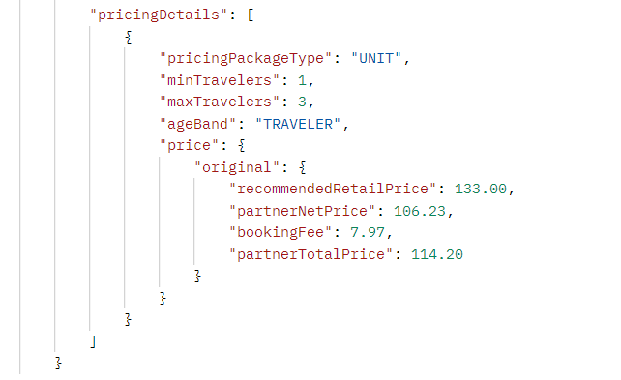
Files submitted:
Additional comments and product code (if different from 118238P2)

- If your implementation supports discounted offers, please share an example of how it has been implemented. Special pricing is returned under price.special along with additional fields indicating booking dates or travel dates when special pricing applies. Below is an example of a current offer for product 103812P7 but you will probably need to find a different product with an active offer.
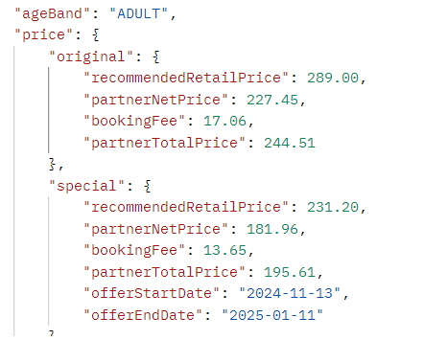
Files submitted:
Product code used, and additional comments

- At what stage of the booking process do you conduct real-time availability and pricing check? (i.e. after the customer selected the date and passenger mix) Do you do it once or multiple times in the booking process?

Additional comments

Product options
Resources:
- API documentation - Product options
- Partner Resource Center - Viator API Certification - Product options

- Using product 3731COLOSSEUM, please demonstrate that a product option includes the following elements: title, description, start time, optionally: total price/price per traveler.
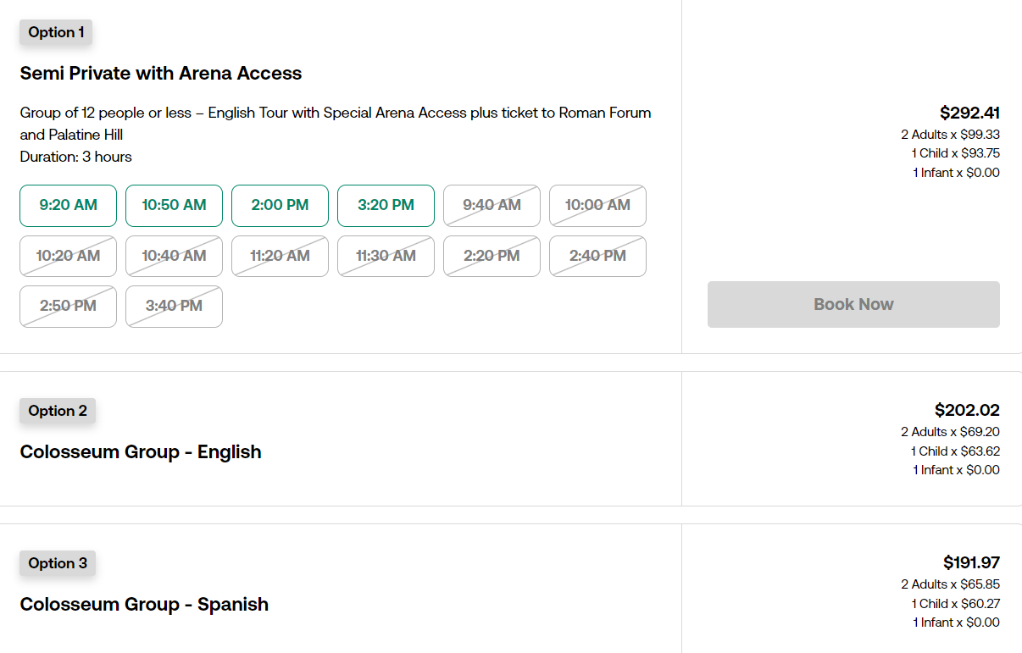
Files submitted:
Additional comments and product code (if different from 3731COLOSSEUM)

- Using product 170456P1 please share screenshots showing that the product option "Self-Drive Single Kayak" (TG1) doesn't come with pickup and product option "With Shuttle Single Kayak" (TG3) includes pickup.

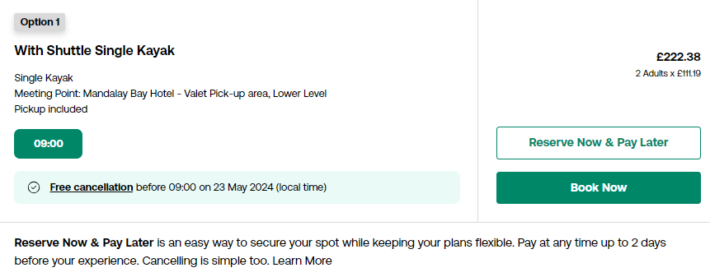
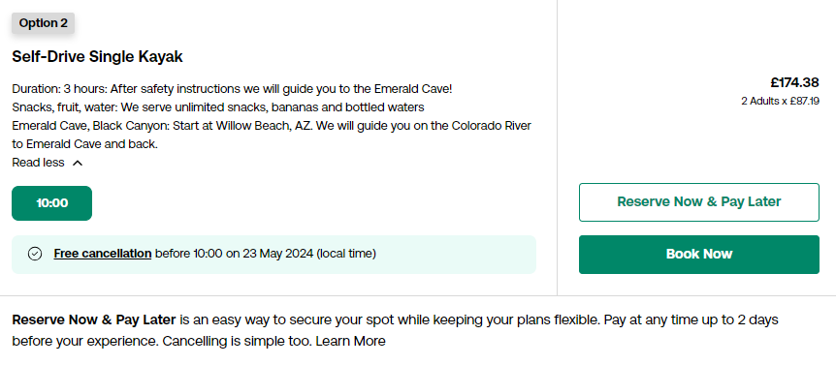
Files submitted:
Additional comments and product code (if different from 170456P1)

- Using 16168P10, please demonstrate that the language options for the tour/activity are displayed at the product option level, and that only one language can be selected. Please share two screenshots showing different language guide selections available for each product option:
- TG1 – English guide only (availability starting June 2026)
- TG4 – English and Spanish guides (availability starting June 2026)
This validation would normally be performed at checkout.

TG1:
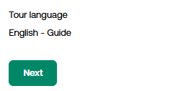

TG4:
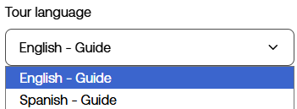

Files submitted:
Additional comments and product code (if different from 16168P10)

Booking questions
Resources:
- API documentation - Booking questions
- Partner Resource Center - Implementing Booking Questions

- Using 186577P3 and selecting at least 2 travelers, please demonstrate that travelers are served with the correct booking questions and that per-person questions are asked separately per traveler. Leaving this field blank should result in an error message.
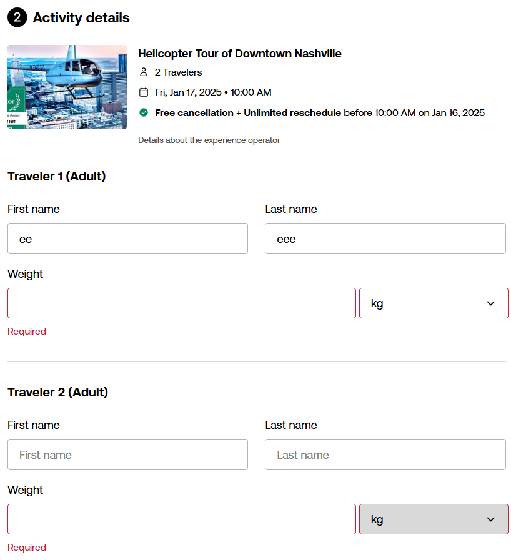

Files submitted:
Additional comments and product code (if different from 186577P3)

- Using 100014P4, show how different arrival options are presented to travelers.
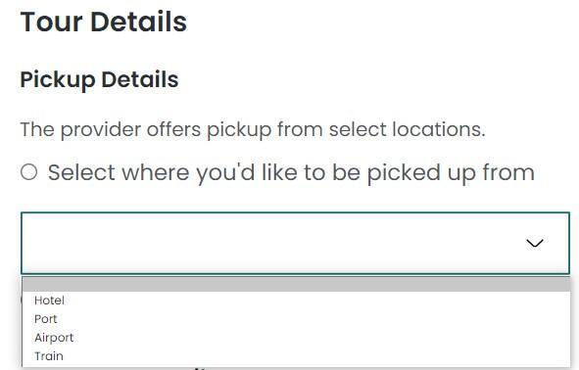
Files submitted:
Additional comments and product code (if different from 100014P4)

- Using 8647P442, show that only arrival modes available for the product are displayed. Based on booking questions returned for this product and locations from logistics.travelerPickup.locations, this product offers pickup from an airport or from a hotel/custom location.
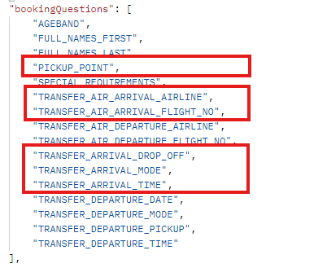
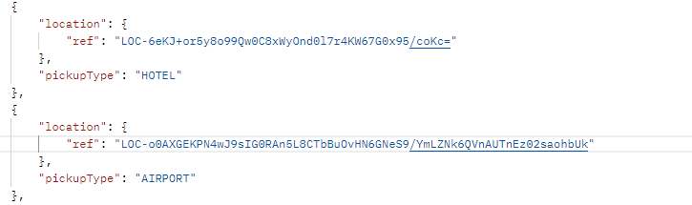
Files submitted:

Additional comments and product code (if different from 8647P442)

- Using 5528292P1, show that only arrival modes available for the product are displayed. This product offers pickup from a train station only.
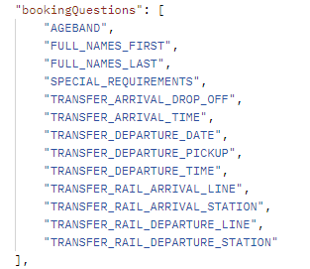
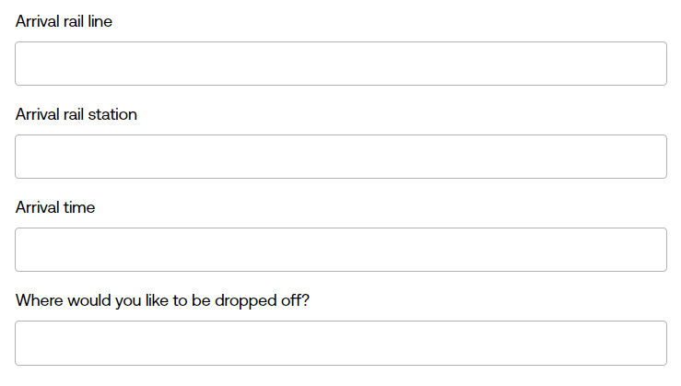
Files submitted:

Additional comments and product code (if different from 5528292P1)

- Using 100014P4, show how conditional booking questions for the selected arrival mode (AIR) are displayed.
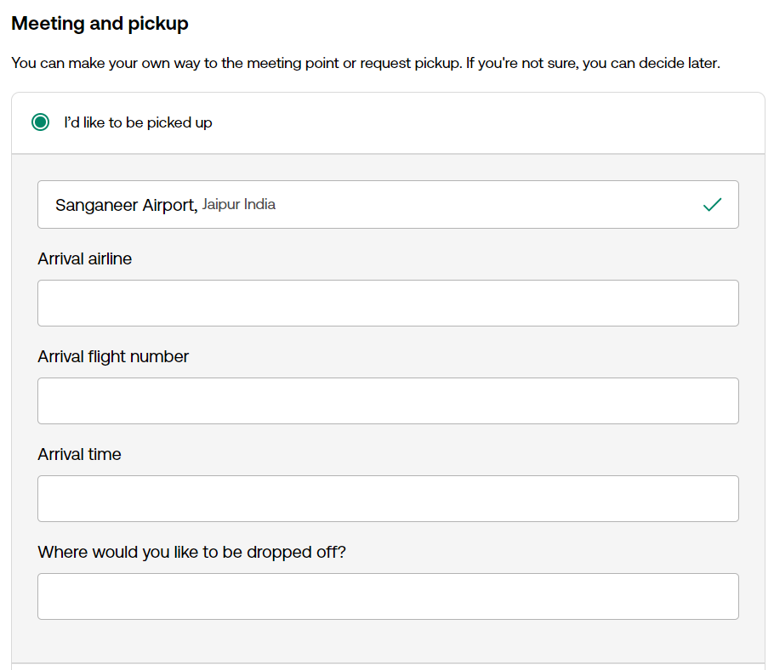
Files submitted:
Additional comments and product code (if different from 100014P4)

- Using 9811P2 please show that only arrival questions returned for the product are displayed (when there is only one arrival mode the TRANSFER_ARRIVAL_MODE question is not returned and conditional booking questions become mandatory).
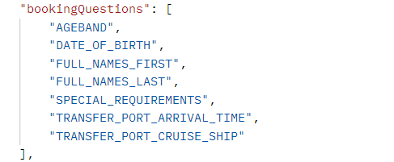
Files submitted:
Additional comments and product code (if different from 9811P2)

- Using 100014P4, please demonstrate that the appropriate list of pickup locations is displayed for a hotel pickup.
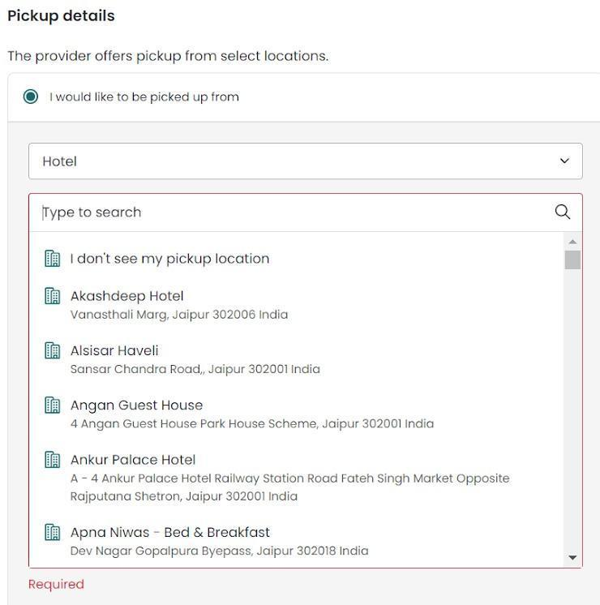
Files submitted:
Additional comments and product code (if different from 100014P4)

- Using 100014P4, please demonstrate that the appropriate list of pickup locations is displayed for an airport pickup.
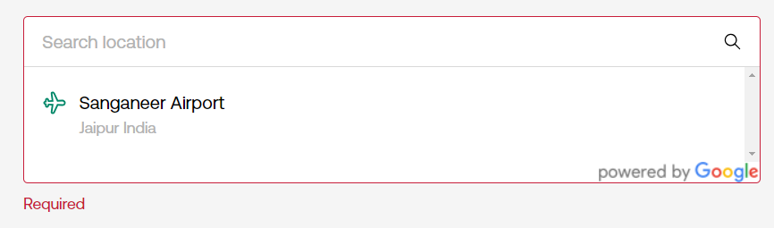
Files submitted:

Additional comments and product code (if different from 100014P4)

- Using 429283P1, please demonstrate that the appropriate list of pickup locations is displayed for a port pickup.
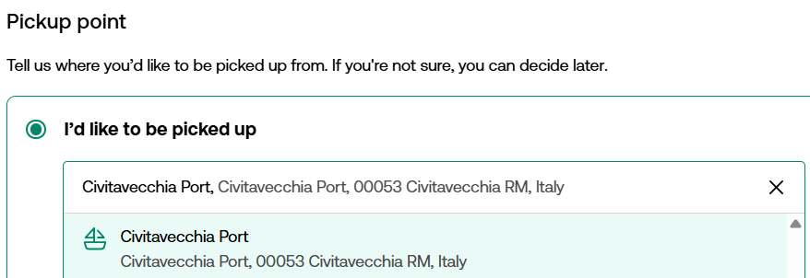

Files submitted:

Additional comments and product code (if different from 429283P1)

- Using 101650P10, please demonstrate that a traveler may enter a custom pickup location in a freetext input field, or decline to enter a location.
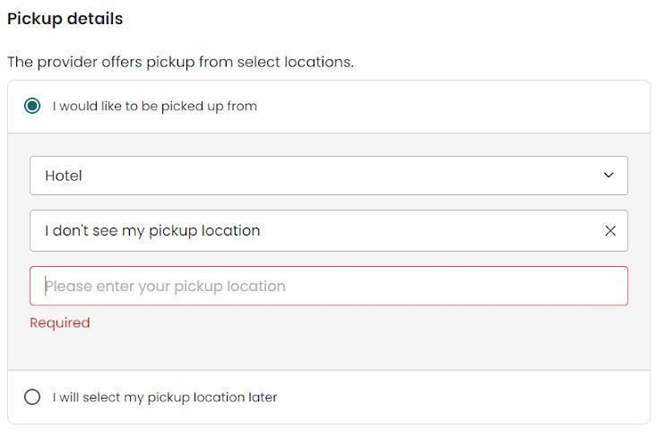
Files submitted:
Additional comments and product code (if different from 101650P10)

- Using 9025P51, please two screenshots:
- One for TG1 (“Share Group Tour”) to demonstrate that travelers are not asked to select the pickup location at checkout if they book the product option "Share Group Tour". If you wish, you can display at checkout the meeting point location but not the pickup locations (travelers shouldn’t be asked to select arrival details or departure details, if the TRANSFER_ARRIVAL_MODE or TRANSFER_DEPARTURE_MODE questions are returned, these must be answered with OTHER in the booking request without asking the customer about arrival/departure modes and the answer to the PICKUP_POINT question must be “MEET_AT_DEAPRTURE_POINT”).
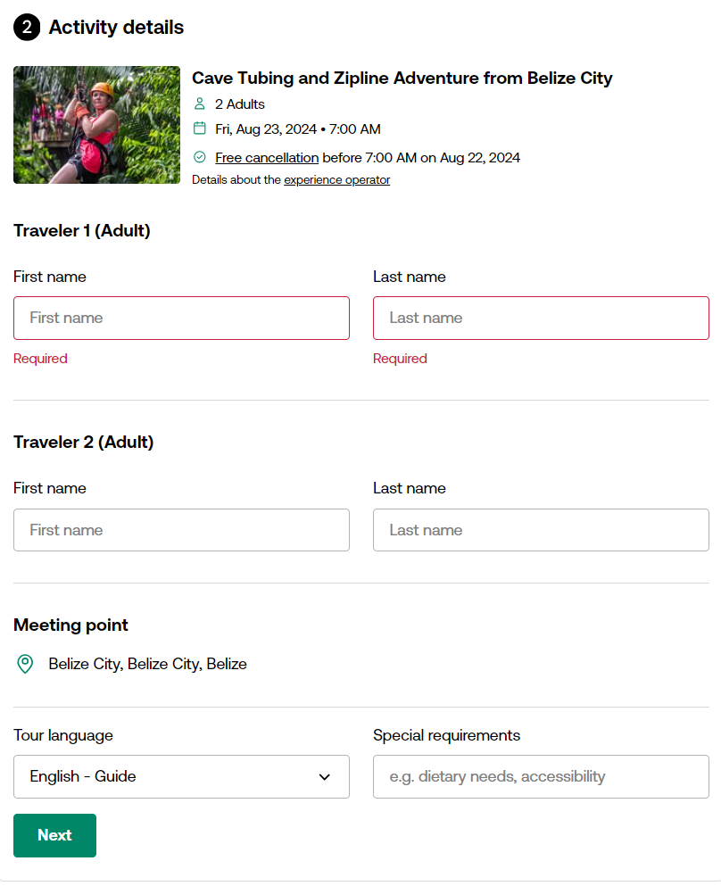
- Another one for TG2 (“Private Tour”) showing that travelers are asked to select the pickup location when booking the product option with pickup.
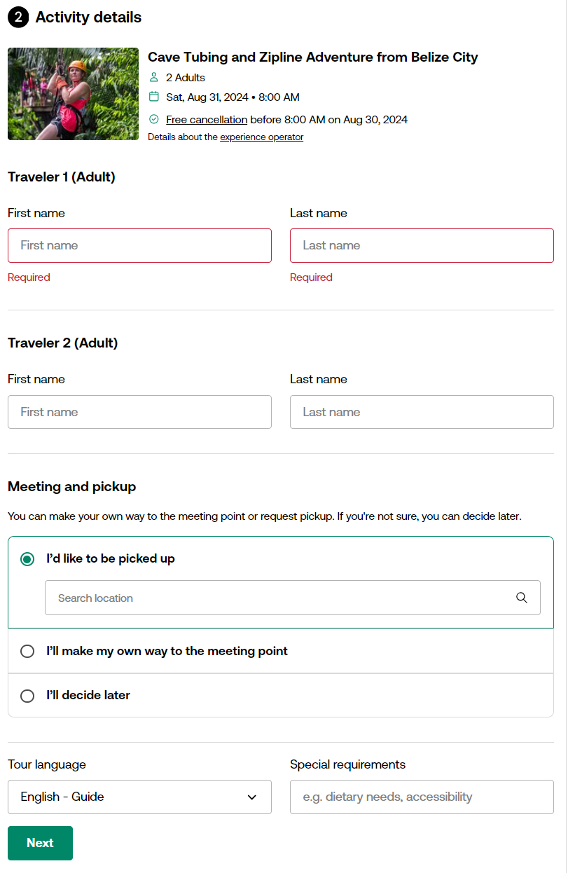
Please share screenshots from the front-end for this check.

Files submitted:
Additional comments and product code (if different from 9025P51)

- Using product 9025P51 please make two bookings:
- One booking for the product option without pickup - "Share Group Tour" (where “MEET_AT_DEAPRTURE_POINT” is sent in the answer to the “PICKUP_POINT” question)
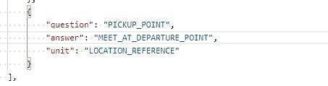
- Another one for the product option with pickup - "Private Tour" (where a location reference is sent in the answer to the “PICKUP_POINT” question).
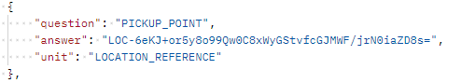
Please share both booking references or logs.
Files submitted:

Additional comments and product code (if different from 9025P51).
- Using 100014P4, please demonstrate that different departure modes are displayed.
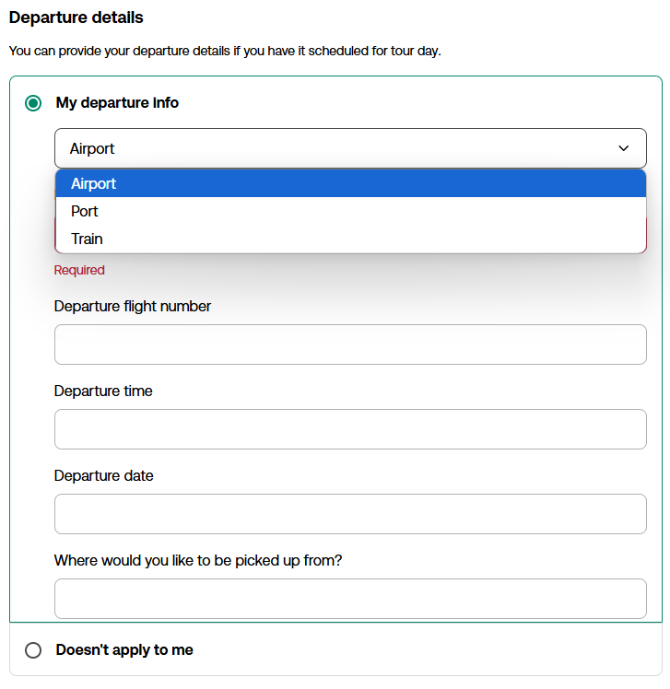
Files submitted:
Additional comments and product code (if different from 100014P4)

- Using 8647P442, please show that departure modes are validated correctly and only departure modes available for the product are displayed.
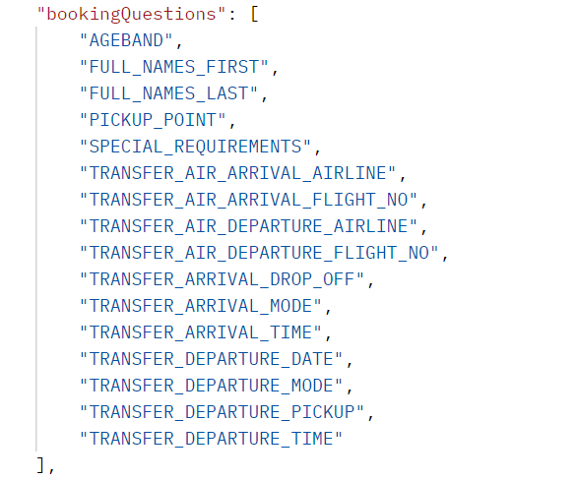
Files submitted:

Additional comments and product code (if different from 8647P442)

- Using 100014P4, please demonstrate that conditional booking questions related to the selected departure mode are asked.
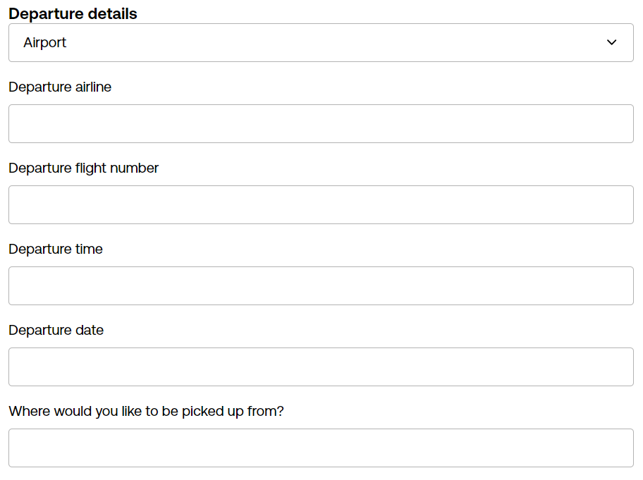
Files submitted:
Additional comments and product code (if different from 100014P4)

- Using 9574P295 please confirm that customers are asked to answer only departure questions returned for the product and don’t have the option to select the departure mode (there is only one).
Note: The implementation of booking questions on the Viator website differs in some cases from the logic in the API. API partners must follow the API logic and ensure that all validations are done correctly to avoid failed bookings.
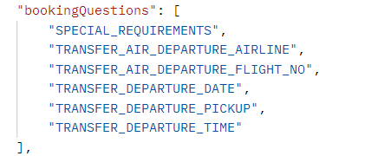
Files submitted:
Additional comments and product code (if different from 9574P295)

- Using product 100014P4, please share two screenshots:
- screenshot with all booking questions displayed when SEA is selected for arrival mode and for departure mode (the TRANSFER_PORT_CRUISE_SHIP must be asked only for arrival-related questions because it can be asked only once per booking)
- screenshot with all booking questions displayed when AIR is selected for arrival mode and SEA is selected for departure mode (the TRANSFER_PORT_CRUISE_SHIP question must be displayed for departure-related questions because it wasn’t asked along with arrival details)
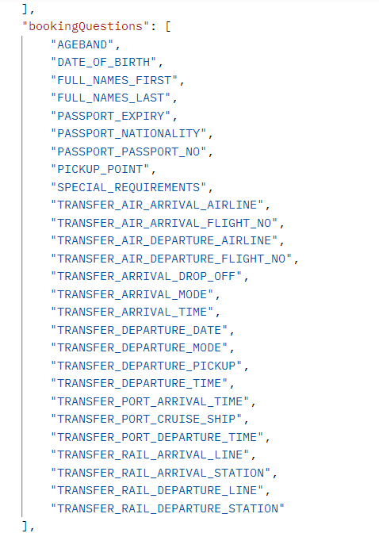

Files submitted:
Additional comments and product code (if different from 100014P4)

Booking page
Resources:
- API documentation - Making a booking
- Partner Resource Center - Viator API Certification - Booking page

- Using any product, please select a travel date and a passenger mix of two or more travelers. Once the checkout page opens, please use a screenshot to demonstrate that a lead traveler is specified, and the names of all travelers are collected
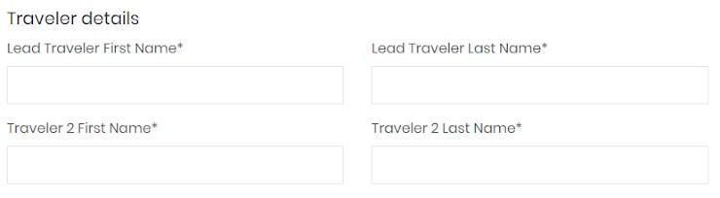
Files submitted:
Additional comments and product code

- Share a screenshot showing how the contact information for the booking is collected.

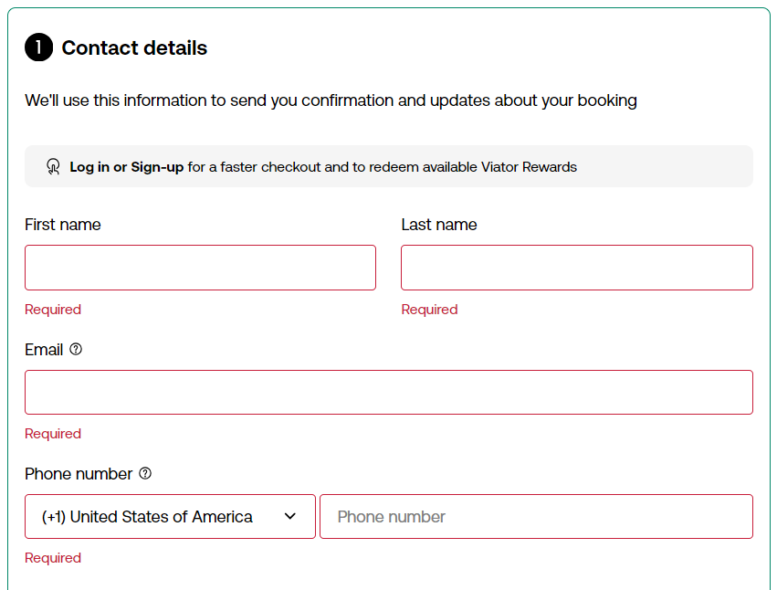
Files submitted:
Additional comments

- Please show the error message displayed when an invalid phone number is provided.
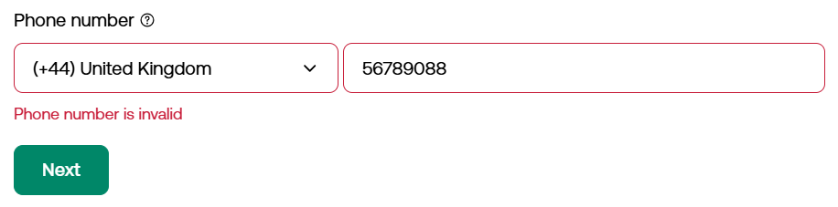
Files submitted:
Additional comments
- Using 445855P9, please demonstrate that different types of language guides are displayed (AUDIO, GUIDE, WRITTEN)
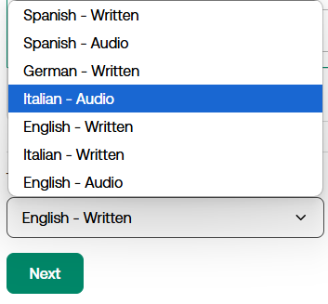
Files submitted:
Additional comments and product code (if different from 445855P9)

- Please share screenshots demonstrating how the cancellation policy is shown to your users on the product display page and the checkout page.
Files submitted:
Additional comments

- Please share a screenshot showing the order summary with all relevant information (tour title, date, time, passenger mix and price)
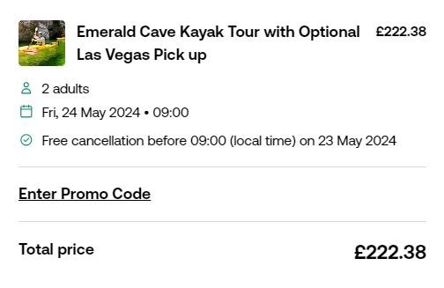
Files submitted:
Product code used, and additional comments

- If you’re an affiliate partner with booking access, please share a screenshot showing that Viator’s Terms of Use and Privacy Policy are included on your checkout pages. Additionally, share the links for each, so we can confirm they redirect to the correct Viator websites.
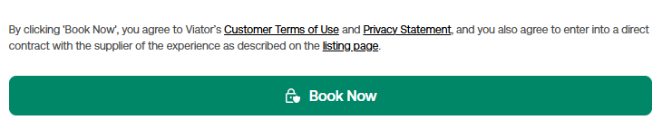
Please note: due to legal requirements, the following text should be displayed on affiliate partner’s sites along with relevant links:
By clicking 'Book Now', you agree to Viator’s Customer Terms of Use and Privacy Statement, and you also agree to enter into a direct contract with the supplier of the experience as described on the listing page.

Files submitted:
Additional comments

Booking confirmation
Resources:
- Partner Resource Center - Viator API Certification - Viator voucher shared with customers

- Please share a screenshot of your booking confirmation page. Travelers should be able to easily see the status of their booking.
Files submitted:
Additional comments

- How is the voucher shared?
- Confirmation page
- Email
- Dashboard
- Other (please specify)
Files submitted:
Additional comments

- If you’re an affiliate partner with booking access and you share the voucher with customers (in addition to the booking confirmation email with the voucher sent by Viator), please provide an example showing how the voucher is delivered for transactions identified as potentially fraudulent.
Note: in such cases the voucher must be shared only via email and not displayed on the booking confirmation page.

Files submitted:
Additional comments

- Please share a screenshot demonstrating the voucher you share with your travelers. Tour operators will not honor a non-standard voucher format.
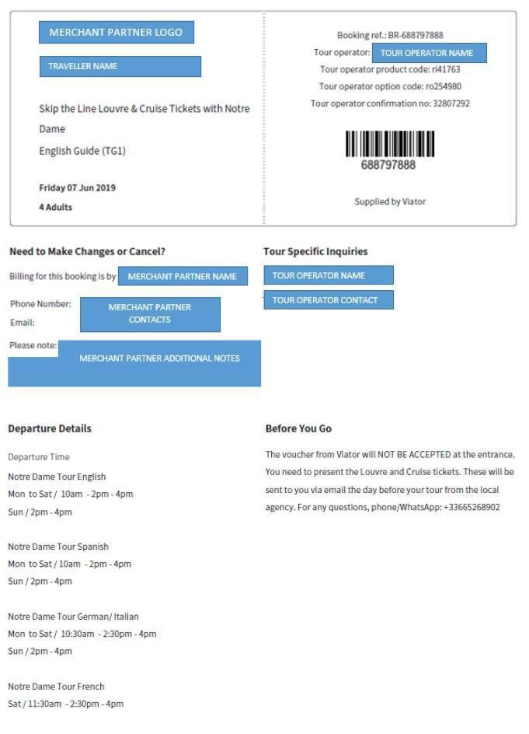
Files submitted:

Additional comments

Traveler cancellations
Resources:
- API documentation - Cancellation API workflow
- Partner Resource Center - All you need to know about cancellations

- Please specify the cancellation policies or policy you have implemented.

- Standard cancellation policy (Viator): full refund up to 24h before experience
- Custom cancellation policy (Viator): cancellation policy customized by tour operator
- All sales final (Viator): no refund is possible
- Custom cancellation policy (partner): a partner's own cancellation terms. Terms must be as strict, or stricter, than those of Viator

Additional comments

- Please share a screenshot showing how the refund amount is communicated to the customer prior to cancelling based on the /cancel-quote response.

Files submitted:

Additional comments

- Please share a screenshot showing how the cancelled booking status is communicated to the customer after the cancellation is processed.

Files submitted:

Additional comments

Supplier cancellations and amendments
Resources:
- API documentation - /bookings-modified-since
- Partner Resource Center - Automating supplier cancellations and amendments

- What is your process for informing travelers about supplier-initiated cancellations and amendments?

Please note: All merchant partners are required to automate the flow for supplier cancellations and amendments using the /bookings/modified-since endpoint. This flow is optional for affiliate partners with booking access - in this case Viator will inform travellers about cancelled bookings using the email address provided in the booking request.
- Email
- Dashboard with booking status updates
- Text message
- Phone call
- App notifications
- Other - please specify

Additional comments

- Please share a screenshot showing how supplier cancellations and amendments are communicated to travelers following the /bookings/modified-since response.

Files submitted:

Additional comments

- Please share a screenshot showing how the refund amount is communicated to the customer following a supplier cancellation, based on the information provided in the /bookings/modified-since response.

Files submitted:

Additional comments

Traveler-initiated amendments
Resources:
- API amendments workflow: a step-by-step guide

- If you have automated the flow for traveler-initiated amendments, please provide screenshots demonstrating how this functionality is implemented on the front end for each step of the flow:
- Amendment check
- Amendment quote (with price details)
- Amendment execution
Please select an amendment that results in a price difference.

Files submitted:

Additional comments

- Please share a screenshot confirming the amendment after it has been processed.

Files submitted:

Additional comments

Manual confirmation type product checks (please answer if you support manual confirmation type products)
Resources:
- API documentation - Booking confirmation types

- Please make a test booking in the sandbox environment for a product with a manual confirmation type. You can use product 20679P14. Make a booking for the product, ensuring that the exp-demo parameter is set to false. If successful, the booking status in the response will have a type of PENDING.
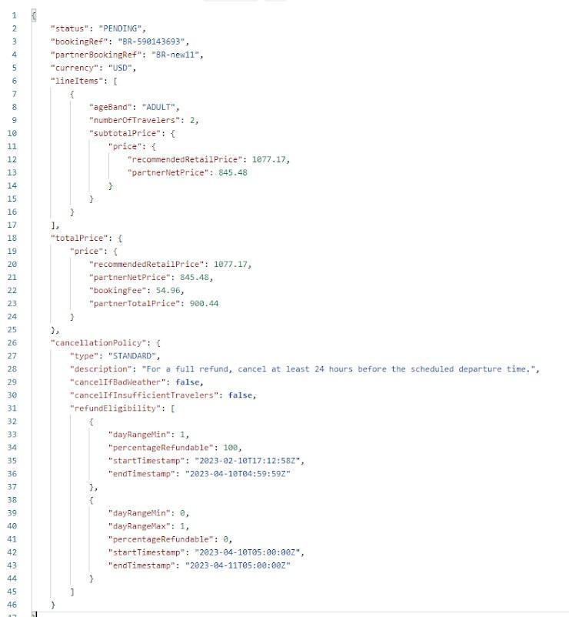
Files submitted:

- Show with a screenshot that the status of the booking on the confirmation page is “pending” and travelers are aware that they need to wait for the booking to be confirmed by the supplier.
Files submitted:
- Please share screenshots showing how all the scenarios below are communicated to the traveler:
- booking confirmed by the supplier
- booking rejected by the supplier
Files submitted:
Additional comments

